 | Data Mining  for Business Analytics  Introduction to Data Science  Spring 2015
Homework #1 | Due: NYU Classes by EOD Wed 2/18

Sahil Goel

Total grade: _______ out of _______ points

Please answer all questions/follow all directions.

- Follow all steps in the WEKA_install_test instructions on NYClasses and include a screenshot of your results.

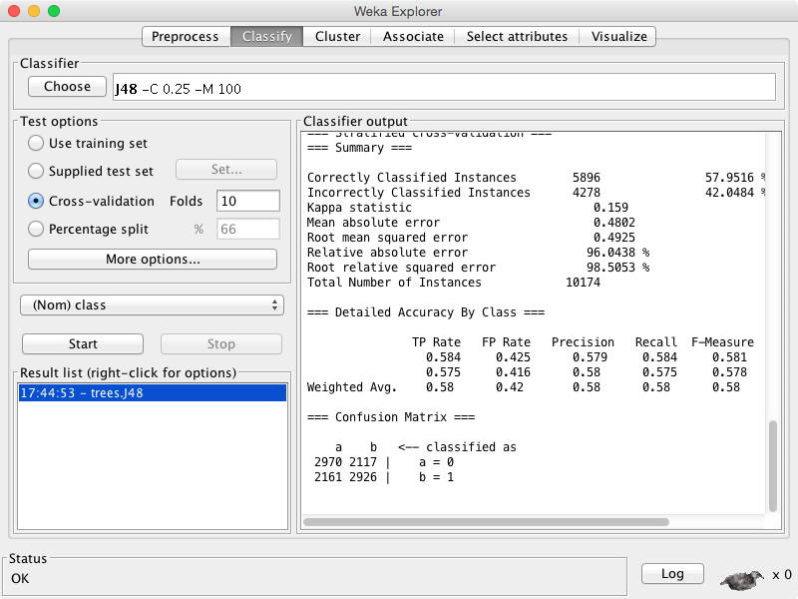

1) Label each case as describing either data mining (DM), or the use of the results of data mining (Use).
a) Use: Choose customers who are most likely to respond to an on-line ad.

b) DM: Discover rules that indicate when an account has been defrauded.

c) DM: Find patterns indicating what customer behavior is more likely to lead to response to an on-line ad.

d) Use: Estimate probability of default for a credit application.

e) Use: Predict whether a customer is pregnant

2) In 2-4 sentences, differentiate “Data Science” and “Big Data”, and also tell how they are related.
How are they related:
They both make use of extremely large datasets, which can’t be handled using traditional techniques.
Differences:
1. Big Data is just storing extremely large data sets whereas Data Science deals with application of sophisticated models on data to make a required decision.
2. Big data is also used to analyze large data sets(such as word count in large data set) where Data Mining deals with complex applications such as predicting next word based on previous word.

3) MTC (MegaTelCo) has decided to use supervised learning to address its problem of churn in its wireless phone business. As a consultant to MTC, you realize that a main task in the business understanding/data understanding phases of the data mining process is to define the target variable. In one or two sentences, please suggest a definition for the target variable. Be as precise as possible—someone else will be implementing your suggestion. (Remember: it should make sense from a business point of view, and it should be reasonable that MTC would have data available to know the value of the target variable for historical customers.)
Ans. 3)
First of all the important task in this case is to find out which clients are going to disconnect their service. So we can use target variable which will tell if the client is going to discontinue his/her service or not. Since we have all the information about past clients and their trends, this is possible using supervised learning. When we have found out those clients, we can give them some promotional offers so that they don’t discontinue their service.

4) Plumbing Inc. has been selling plumbing supplies for the last 20 years. The owner, Joe, decides that next year it is time to diversify by adding gardening tools to the products. Having had success using customer data to build predictive models to guide direct mail campaigns for special plumbing offers, he considers that data mining could help him to identify a subset of customers who should be good prospects for his new set of products. Is Joe ready to solve this as a supervised learning problem?
If no - why not?
Because, from past data we don’t know the result of the model and that’s why we can’t apply supervised learning algorithm i.e. suppose we choose target variable as predicting who uses gardening tools, but since we have no information about the outcome of the model i.e. if a person will use gardening tools or not, we can’t apply supervised learning algorithm.

